Staff Report
Meeting Date: November 12, 2024
To: Siskiyou County Board of Supervisors
From: Bernadette Cizin, Associate Planner
Subject: Proposed Carmichael & Manley Williamson Act Rescission with Re-entry, Agricultural Preserve Amendment (APA-24-10) and CEQA Determination

Background and Discussion
On July 26, 2024, the County received an application for a Williamson Act Contract amendment which proposes to remove approximately 340.14 acres, owned by the Carmichaels and 74.94 acres owned by the Manleys, from the existing Williamson Act contracts which currently have multiple property owners. They propose to continue the existing Agricultural Use of rangeland and pasture for livestock production and forage. Also, the existing Agricultural Preserve does not meet current standards and should be amended to remove the subject property and a new Agricultural Preserve created.
During the initial review of the project, it was found that one of the subject parcels, APN 052-360-090 is substandard in size (under the 40-acre minimum requirement). The applicant was notified that because this parcel is only 23 acres, it does not meet the minimum parcel size requirement and would be recommended for non-renewal. It was also explained that the owner did have the option to apply to adjust the property boundary to increase the size of this parcel to over 40 acres. The owner is not opposed to the issuance of a Notice of Non-Renewal for this parcel and has requested that the application move forward as submitted.
This project does not propose to remove or add property to the existing agricultural preserves.
Agricultural Preserve Administrator Review
Staff prepared a detailed report (Exhibit D) for review and recommendation by the Agricultural Preserve Administrator. Based on the report, the Administrator found the applicant’s request is consistent with the County Rules for the Establishment and Administration of Agricultural Preserves and Williamson Act Contracts and recommends the Board rescind and reissue the contract as proposed and amend the existing preserves to remove the subject property and establish a new agricultural preserve. The Administrator also recommends that the Board direct staff to issue a Notice of Non-Renewal for the 23-acre parcel.

Environmental Review
Staff is proposing that the proposed project be considered categorically exempt from the California Environmental Quality Act (CEQA) pursuant to CEQA Guidelines Section 15317, Open Space Easements or Contracts. A Categorical Exemption implies that the project will not result in any significant adverse environmental effects. CEQA Guidelines Section 15317 specifically exempts the making and renewing of open space contracts under the Williamson Act, which is applicable to the subject action.
The Board of Supervisors must consider the proposed CEQA exemption together with any comments received during the public review process. Further, the exemption can only be approved if the Board finds, based on the whole record before it, that there is not substantial evidence that the project will have a significant effect on the environment. Accordingly, a finding to this effect has been incorporated into both draft resolutions prepared for the Board’s consideration.
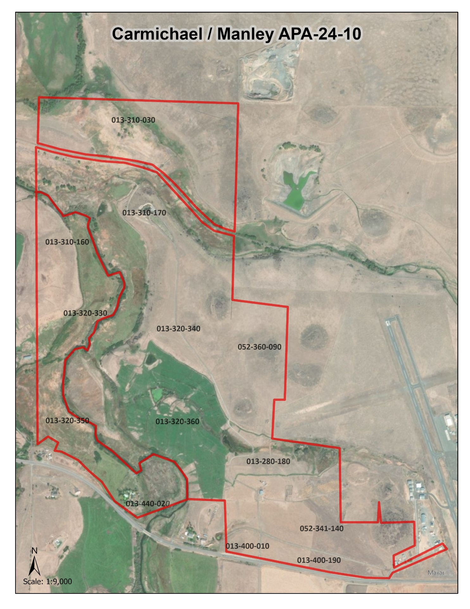
Figure 1: Subject Parcels

Comments
Agency Comments

Siskiyou County Assessor – August 14, 2024
The Assessor’s office has provided estimated tax assessment values for the one parcel included in this project (Exhibit D).
Planning Response: No Response necessary.
Public Comments
Notice of the project was published and posted as required prior to the Board of Supervisors meeting and no public comment was received as of the preparation of this staff report.

Recommended Action
Should the Board of Supervisors concur with staff’s analysis, staff recommends that the Board of Supervisors find that the proposed modifications to the Williamson Act contract and Agricultural Preserve are exempt from CEQA and approve said modifications.
A draft motion to this effect is provided below.

Recommended Motions
I move to take the following actions:
- Determine the project exempt from CEQA in accordance with Section 15317, Open Space Easements or Contracts; and
- Adopt the attached resolution approving amendment to the existing Agricultural Preserve and establishment of a new preserve; and
- Adopt the attached resolution approving the rescission and reentry of the applicable Williamson Act contract; and
- Adopt the attached resolution directing staff to process the Notice of Non-Renewal for the 23-acre substandard parcel, with any changes directed by the Board.

Exhibits to the Staff Report
- Draft Resolution amending the existing Agricultural Preserve and establishing a new preserve
- Draft Resolution Approving the Rescission of the subject property from the existing contracts and Reentry into a new Williamson Act Contract
- Exhibit A within Draft Resolution: Williamson Act Contract Carmichael – DRAFT
- Exhibit B within Draft Resolution: Williamson Act Contract Manley - DRAFT
- Draft Resolution directing staff to issue a Notice of Non-Renewal for 23-acre substandard parcel
      - Exhibit A within Draft Resolution: List of Parcels and Map
      - Exhibit A within Draft Resolution: Notice of Non-Renewal – DRAFT
- Agricultural Preserve Administrator Staff Report with Recommendation
- Comments

